**ADA Homework 8**

**Wenxin Liang UNI:wl2455**

Consider the data in Table 1 on mental health.

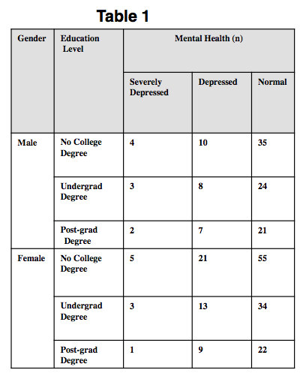

**Question 1**

**Categorize Mental Health as a binary variable, with values 0, if Normal, and 1, Otherwise; and Education Level with values 0 if No College Degree, and 1 otherwise.**

Based on R, we categorized Mental Health and Education Level as followed,

> Data_Mental <- read.table("/Users/Wenxin_AN/Documents/Master/ada/MENTAL HEALTH.csv",sep=";",header=TRUE)

> Education <- 1*(!Data_Mental$Education.Level =="No College Degree")

> Mental <- 1*(!Data_Mental$Mental.Health == "Normal")

> table(Mental,Education)

Education

Mental 0 1

0 90 101

1 40 46

**a)  Determine whether there is association between Education Level and Mental Health, using logistic regression, without adjusting for Gender. Interpret what the estimated parameters denote.**

Based on the question since without adjusting for Gender, we have,

$$X_{1}=\left\{\begin{aligned}0 No College Degree \\ 1 Otherwise\end{aligned}\right.$$

$$Y=\left\{\begin{aligned}0 Normal \\ 1 Otherwise\end{aligned}\right.$$

Let $p_{x}$ denote the probability of having mental health (severely depressed, depressed) given education level of the individual. Then we have $p_{x}=\frac{e^{β_{0}+β_{1}X_{1}}}{1+e^{β_{0}+β_{1}X_{1}}}$

In terms of the link function we obtain,

$$logit\left(p_{x}\right)=β_{0}+β_{1}X_{1}$$

When $X_{1}=0$ which means when the education level is no college degree, $logit\left(p_{x}\right)=β_{0}$, which gives,

$$exp\left\{β_{0}\right\}=\frac{p_{0}}{1-p_{0}}$$

We obtain $exp\left\{β_{0}\right\}$ is the odds of having mental health (severely depressed, depressed) for no college degree.

When $X_{1}=1$ which means the education level is otherwise (undergrad degree or post-grad degree), $logit\left(p_{x}\right)=β_{0}+β_{1}$, which gives,

$β_{1}=logit\left(p_{1}\right)-β_{0}$ or $β_{1}=ln\frac{p_{1}}{1-p_{1}}-ln\frac{p_{0}}{1-p_{0}}$

We obtain $β_{1}$ is the log odds ratio of having mental health (severely depressed, depressed) for the education level is otherwise (undergrad degree or post-grad degree).

Based on R, we get

> fit1_1 <- glm(Mental ~ Education,family = "binomial")

> summary(fit1_1)

Call:

glm(formula = Mental ~ Education, family = "binomial")

Deviance Residuals:

Min 1Q Median 3Q Max

-0.8664 -0.8664 -0.8576 1.5243 1.5353

Coefficients:

Estimate Std. Error z value Pr(>|z|)

(Intercept) -0.81093 0.19003 -4.267 1.98e-05 ***

Education 0.02445 0.26029 0.094 0.925

---

Signif. codes: 0 ‘***’ 0.001 ‘**’ 0.01 ‘*’ 0.05 ‘.’ 0.1 ‘ ’ 1

(Dispersion parameter for binomial family taken to be 1)

Null deviance: 343.19 on 276 degrees of freedom

Residual deviance: 343.18 on 275 degrees of freedom

AIC: 347.18

Number of Fisher Scoring iterations: 4

Therefore, we can conclude that,

$$β_{0}=-0.81093$$

$$β_{1}=0.02445$$

Since $exp\left\{β_{1}\right\}=1.024751≈1$, all the coefficients of the estimated parameters are not significant so we conclude that there is no association between Education Level and Mental Health.

$β_{0}=-0.81093$ denotes the log odds of having mental health (severely depressed, depressed) for no college degree.

$β_{1}=0.02445$ denotes the log odds ratio of having mental health (severely depressed, depressed) for the education level is otherwise (undergrad degree or post-grad degree) relative to education level is no college degree.

**b)  Repeat (a) adjusting for Gender. Interpret what the estimated parameters denote.**

> Gender <- 1*(Data_Mental$Gender == "Male")

> table(Mental,Education,Gender)

, , Gender = 0

Education

Mental 0 1

0 55 56

1 26 26

, , Gender = 1

Education

Mental 0 1

0 35 45

1 14 20

> fit2 <- glm(Mental ~ Education+Gender, family ="binomial")

> summary(fit2)

Call:

glm(formula = Mental ~ Education + Gender, family = "binomial")

Deviance Residuals:

Min 1Q Median 3Q Max

-0.8822 -0.8709 -0.8463 1.5047 1.5635

Coefficients:

Estimate Std. Error z value Pr(>|z|)

(Intercept) -0.77389 0.21369 -3.622 0.000293 ***

Education 0.03093 0.26093 0.119 0.905633

Gender -0.09946 0.26545 -0.375 0.707897

---

Signif. codes: 0 ‘***’ 0.001 ‘**’ 0.01 ‘*’ 0.05 ‘.’ 0.1 ‘ ’ 1

(Dispersion parameter for binomial family taken to be 1)

Null deviance: 343.19 on 276 degrees of freedom

Residual deviance: 343.04 on 274 degrees of freedom

AIC: 349.04

Number of Fisher Scoring iterations: 4

Since $exp\left\{β_{1}\right\}=1.031416≈1$, all the coefficients of the estimated parameters are not significant so we conclude that there is no association between Education Level and Mental Health.

$β_{0}=-0.77389$ denotes the log odds of having mental health (severely depressed, depressed) for no college degree and female.

$β_{1}=0.03093$ denotes the log odds ratio of having mental health (severely depressed, depressed) for the education level is otherwise (undergrad degree or post-grad degree) relative to no college degree and for any gender (male or female).

$β_{2}=-0.09946$ denotes the log odds ratio of having mental health (severely depressed, depressed) for male relative to female for any education level (undergrad degree or post-grad degree).

> fit2_1 <- glm(Mental ~ Education+Gender+Education*Gender, family ="binomial")

> summary(fit2_1)

Call:

glm(formula = Mental ~ Education + Gender + Education * Gender,

family = "binomial")

Deviance Residuals:

Min 1Q Median 3Q Max

-0.8799 -0.8733 -0.8576 1.5075 1.5829

Coefficients:

Estimate Std. Error z value Pr(>|z|)

(Intercept) -0.74924 0.23800 -3.148 0.00164 **

Education -0.01802 0.33610 -0.054 0.95725

Gender -0.16705 0.39578 -0.422 0.67296

Education:Gender 0.12338 0.53403 0.231 0.81729

---

Signif. codes: 0 ‘***’ 0.001 ‘**’ 0.01 ‘*’ 0.05 ‘.’ 0.1 ‘ ’ 1

(Dispersion parameter for binomial family taken to be 1)

Null deviance: 343.19 on 276 degrees of freedom

Residual deviance: 342.99 on 273 degrees of freedom

AIC: 350.99

Number of Fisher Scoring iterations: 4

Since $exp\left\{β_{1}\right\}=0.9821414≈1$, all the coefficients of the estimated parameters are not significant so we conclude that there is no association between Education Level and Mental Health.

**c)  Assess whether it is appropriate to pool data across male and female subjects using a suitable logistic regression model.**

Since all the coefficients of the estimated parameters in the model in part a which do not adjust for Gender and in the models in part b which adjusting for Gender are not significant then we can conclude are there is no association between Education Level and Mental Health and Gender do not have so much influence to Mental. Then it is appropriate to pool data across male and female subjects using a suitable logistic regression model.

Also we can use the woolf test to verify,

> woolf <- function(x) {

+ x <- x + 1 / 2

+ k <- dim(x)[3]

+ or <- apply(x, 3, function(x) (x[1,1]*x[2,2])/(x[1,2]*x[2,1]))

+ w <- apply(x, 3, function(x) 1 / sum(1 / x))

+ 1 - pchisq(sum(w * (log(or) - weighted.mean(log(or), w)) ^ 2), k - 1)

+ }

> woolf(table(Mental,Education,Gender))

[1] 0.826266

Since we obtain the p-value=0.826266>0.05 so we fail to reject the null hypothesis then we conclude that there is no significant heterogeneity. Then it is appropriate to pool data across male and female subjects.

**Question 2**

**Repeat 1 (a) - 1 (c) above now using Educational Background as a trichotomous variable, i.e., No College Degree, Undergrad Degree, Post-grad Degree.**

> # "No College Degree" as the reference group

> Edu.ud <- 1*(!Data_Mental$Education.Level =="Undergrad Degree")

> Edu.pd <- 1*(!Data_Mental$Education.Level =="Post-grad Degree")

>

**Part a. Determine whether there is association between Education Level and Mental Health, using logistic regression, without adjusting for Gender. Interpret what the estimated parameters denote.**

> # Part a

> fit3 <- glm(Mental ~ Edu.ud+Edu.pd, family = "binomial")

> summary(fit3)

Call:

glm(formula = Mental ~ Edu.ud + Edu.pd, family = "binomial")

Deviance Residuals:

Min 1Q Median 3Q Max

-0.8743 -0.8576 -0.8576 1.5145 1.5380

Coefficients:

Estimate Std. Error z value Pr(>|z|)

(Intercept) -0.770437 0.407771 -1.889 0.0588 .

Edu.ud -0.046324 0.300648 -0.154 0.8775

Edu.pd 0.005831 0.334662 0.017 0.9861

---

Signif. codes: 0 ‘***’ 0.001 ‘**’ 0.01 ‘*’ 0.05 ‘.’ 0.1 ‘ ’ 1

(Dispersion parameter for binomial family taken to be 1)

Null deviance: 343.19 on 276 degrees of freedom

Residual deviance: 343.16 on 274 degrees of freedom

AIC: 349.16

Number of Fisher Scoring iterations: 4

Since $exp\left\{β_{1}\right\}=0.9547326≈1$ and $exp\left\{β_{2}\right\}=1.005848≈1$, all the coefficients of the estimated parameters are not significant so we conclude that there is no association between Education Level and Mental Health.

$β_{0}=-0.770437$ denotes the log odds of having mental health (severely depressed, depressed) relative to no college degree.

$β_{1}=-0.046324$ denotes the log odds ratio of having mental health (severely depressed, depressed) for the education level is undergrad degree relative to education level is no college degree.

$β_{2}=0.005831$ denotes the log odds ratio of having mental health (severely depressed, depressed) for the education level is post-grad degree relative to education level is no college degree.

**b)  Repeat (a) adjusting for Gender. Interpret what the estimated parameters denote.**

> fit4 <- glm(Mental ~ Edu.ud+Edu.pd+Gender, family = "binomial")

> summary(fit4)

Call:

glm(formula = Mental ~ Edu.ud + Edu.pd + Gender, family = "binomial")

Deviance Residuals:

Min 1Q Median 3Q Max

-0.8889 -0.8707 -0.8374 1.5169 1.5630

Coefficients:

Estimate Std. Error z value Pr(>|z|)

(Intercept) -0.720206 0.429767 -1.676 0.0938 .

Edu.ud -0.049738 0.300866 -0.165 0.8687

Edu.pd -0.004591 0.335937 -0.014 0.9891

Gender -0.097709 0.265819 -0.368 0.7132

---

Signif. codes: 0 ‘***’ 0.001 ‘**’ 0.01 ‘*’ 0.05 ‘.’ 0.1 ‘ ’ 1

(Dispersion parameter for binomial family taken to be 1)

Null deviance: 343.19 on 276 degrees of freedom

Residual deviance: 343.02 on 273 degrees of freedom

AIC: 351.02

Number of Fisher Scoring iterations: 4

Since $exp\left\{β_{1}\right\}=0.9514787≈1$ and $exp\left\{β_{2}\right\}=0.9954195≈1$, all the coefficients of the estimated parameters are not significant so we conclude that there is no association between Education Level and Mental Health when adjusting for Gender.

$β_{0}=-0.720206$ denotes the log odds of having mental health (severely depressed, depressed) for no college degree and female.

$β_{1}=-0.049738$ denotes the log odds ratio of having mental health (severely depressed, depressed) for the education level undergrad degree relative to no college degree and for any gender (male or female).

$β_{2}=-0.004591$ denotes the log odds ratio of having mental health (severely depressed, depressed) for the education level post-grad degree relative to no college degree and for any gender (male or female).

$β_{3}=-0.097709$ denotes the log odds ratio of having mental health (severely depressed, depressed) for male relative to female for any education level (undergrad degree or post-grad degree).

**c)  Assess whether it is appropriate to pool data across male and female subjects using a suitable logistic regression model.**

Since all the coefficients of the estimated parameters in the model in part a which do not adjust for Gender and in the models in part b which adjusting for Gender are not significant then we can conclude are there is no association between Education Level and Mental Health and Gender do not have so much influence to Mental. Then it is appropriate to pool data across male and female subjects using a suitable logistic regression model. Also here we can conclude that it is appropriate to pool data across Education level subjects using a suitable logistic regression model.

**Question 3 Repeat 1 (b) using the lasso**

> library(glmnet)

> X <- model.matrix(Mental~Education+Gender)

> y <- Mental

> fit <- glmnet(X,y)

> cvfit <- cv.glmnet(X,y)

> plot(cvfit)

> cv_out <- cv.glmnet(X,y,alpha=1,family="binomial")

> bestlammin <- cv_out$lambda.min

> result <- glmnet(X,y,alpha=1,family="binomial")

> lasso.coef <- predict(result,type="coefficients",s=bestlammin)

> lasso.coef

4 x 1 sparse Matrix of class "dgCMatrix"

1

(Intercept) -0.7979261

(Intercept) .

Education .

Gender .

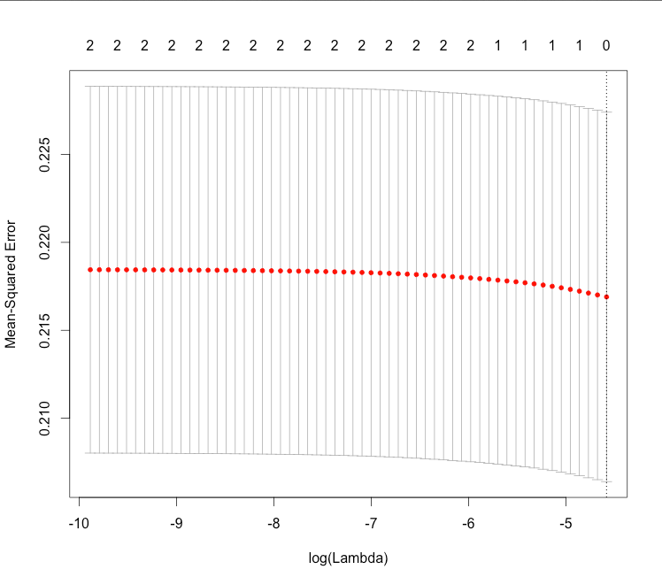

Based Lasso procedure the final model includes only the intercept term, which means we drop down all the predictors, Education Level and Gender, since the other predictors are not significant. This result is corresponding to the result we obtain in Question 1 part b. Then we conclude that there is no association between Education Level and Mental Health.

The code followed,

#Homework 8

# Question 1

Data_Mental <- read.table("/Users/Wenxin_AN/Documents/Master/ada/MENTAL HEALTH.csv",sep=";",header=TRUE)

Education <- 1*(!Data_Mental$Education.Level =="No College Degree")

Mental <- 1*(!Data_Mental$Mental.Health == "Normal")

table(Mental,Education)

# Part a

fit1_1 <- glm(Mental ~ Education,family = "binomial")

summary(fit1_1)

exp(0.02445)

# Part b

Gender <- 1*(Data_Mental$Gender == "Male")

table(Mental,Education,Gender)

fit2 <- glm(Mental ~ Education+Gender, family ="binomial")

summary(fit2)

exp(0.030933)

fit2_1 <- glm(Mental ~ Education+Gender+Education*Gender, family ="binomial")

summary(fit2_1)

exp(-0.01802)

# Part c

woolf <- function(x) {

x <- x + 1 / 2

k <- dim(x)[3]

or <- apply(x, 3, function(x) (x[1,1]*x[2,2])/(x[1,2]*x[2,1]))

w <- apply(x, 3, function(x) 1 / sum(1 / x))

1 - pchisq(sum(w * (log(or) - weighted.mean(log(or), w)) ^ 2), k - 1)

}

woolf(table(Mental,Education,Gender))

# Question 2

# "No College Degree" as the reference group

Edu.ud <- 1*(!Data_Mental$Education.Level =="Undergrad Degree")

Edu.pd <- 1*(!Data_Mental$Education.Level =="Post-grad Degree")

# Part a

fit3 <- glm(Mental ~ Edu.ud+Edu.pd, family = "binomial")

summary(fit3)

exp(-0.046324)

exp(0.005831)

# Part b

fit4 <- glm(Mental ~ Edu.ud+Edu.pd+Gender, family = "binomial")

summary(fit4)

exp(-0.049738)

exp(-0.004591)

# Part c

# Question 3

library(glmnet)

X <- model.matrix(Mental~Education+Gender)

y <- Mental

fit <- glmnet(X,y)

cvfit <- cv.glmnet(X,y)

plot(cvfit)

cv_out <- cv.glmnet(X,y,alpha=1)

bestlammin <- cv_out$lambda.min

result <- glmnet(X,y,alpha=1)

lasso.coef <- predict(result,type="coefficients",s=bestlammin)

lasso.coef